Network Mapping (NMAP)
- Monitoring ARP Ping on Wireshark.
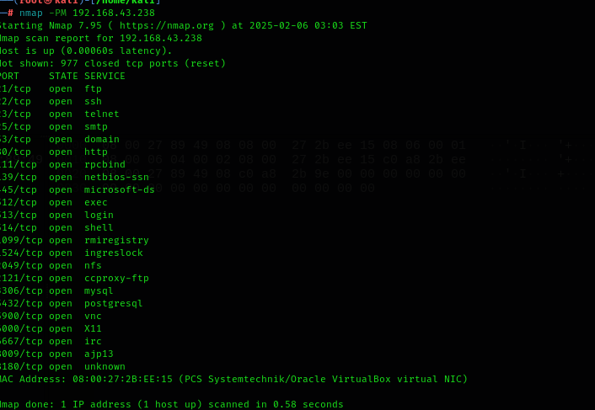
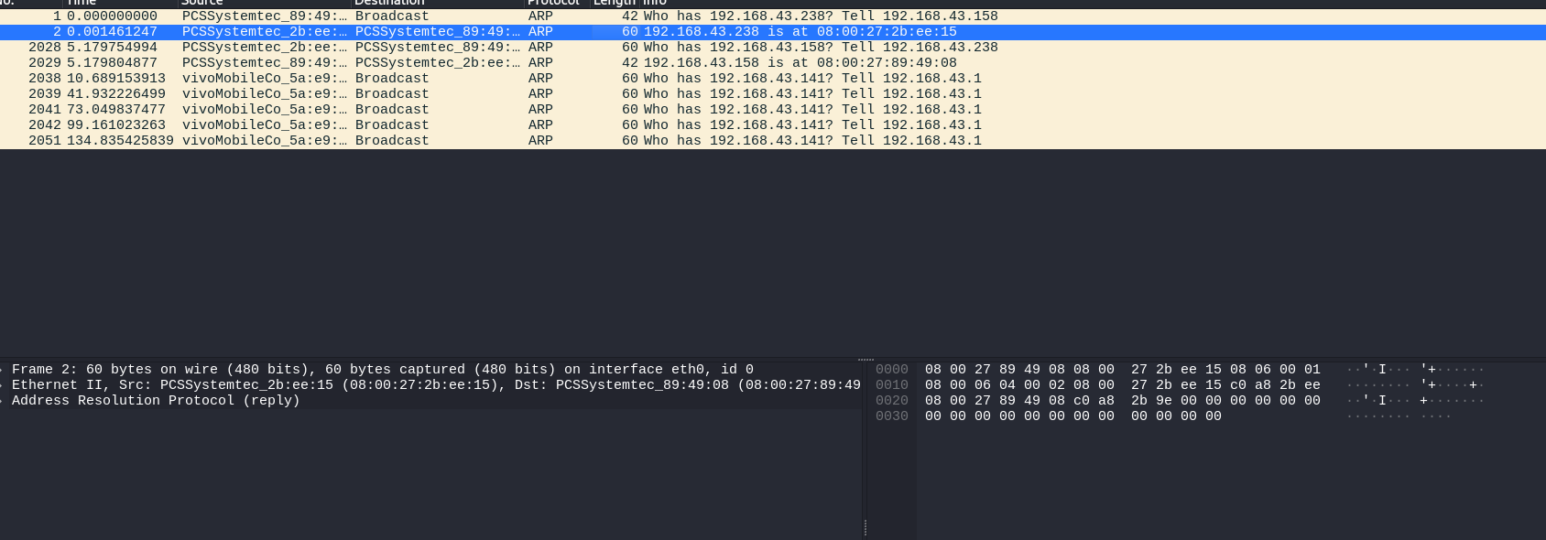
Target IP address
ICMP Mask Ping
Here is the MAC address of Targeted IP
- Performing ARP (Address Resolution Protocol) Ping on KALI.
1. ARP: ARP (Address Resolution Protocol) is a network protocol used to map an IP address (Layer 3) to a MAC address (Layer 2) within a local network (LAN).
ARP Features:
Host wants to communicate with another device on the same network.
Checks ARP cache: If the MAC address of the target IP is already known, it uses it.
If not found, sends an ARP Request (Broadcast):
- The sender device asks, "Who has IP 192.168.43.238? Tell me your MAC address."
The target device responds with an ARP Reply (Unicast):
- The target replies, "I am 192.168.43.238, and my MAC address is 08:00:27:2B:EE:15."
The sender updates its ARP table and sends the actual data.
List of Content:
- ARP Ping
- ICMP Address Mask Ping
- ICMP Echo Ping
- ICMP Timestamp Ping
- Ping Scan
- TCP ACK Ping
- TCP Scan Ping
- UDP Ping

ARP Ping can be seen here
Nmap – This is the Network Mapper tool, used for network discovery and security auditing.
PM – It is used for ICMP Mask Ping.
192.168.43.238 – This is the target IP address in a private network.
An ICMP Address Mask Request is used to query a host for its subnet mask. The expected response is an ICMP Address Mask Reply, which contains the subnet mask of the target device.
2. ICMP Address Mask Ping:
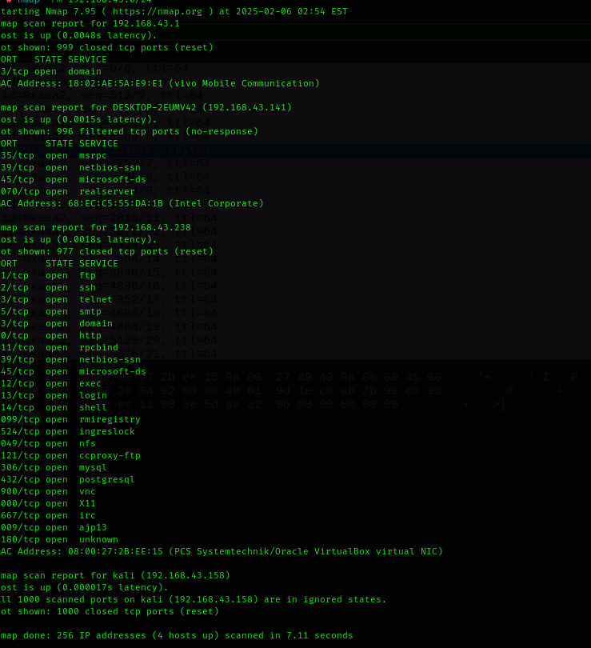
-PM:
The -PM option sends an ICMP Address Mask Request packet to the target.
It is used to request the subnet mask of the target device.
This type of ICMP request was mainly used in older network devices, but most modern systems ignore or block this request for security reasons.
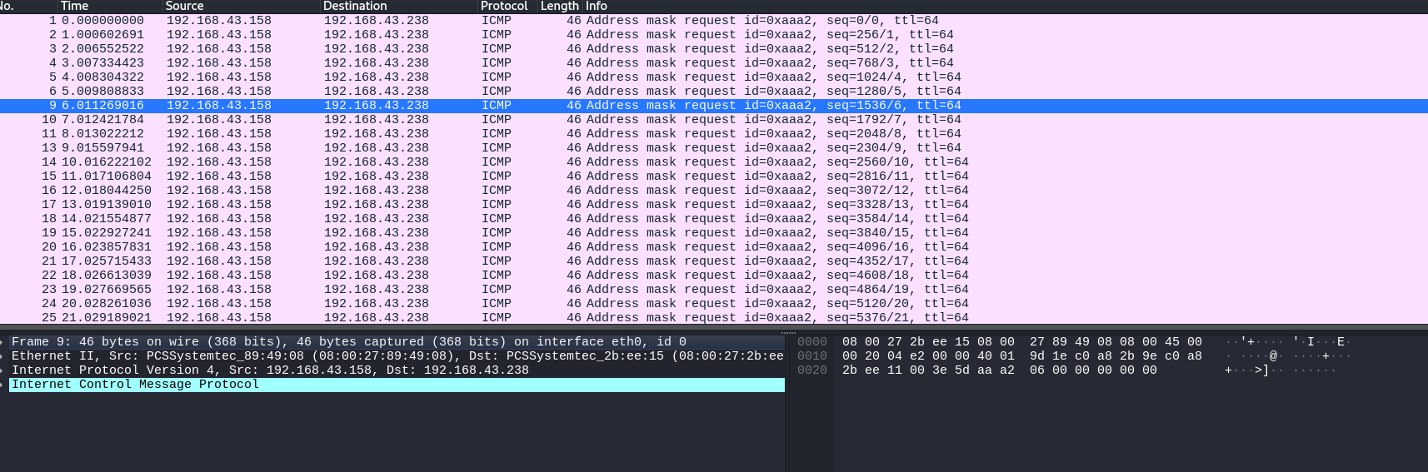
ICMP Ping info
ICMP Protocol

